**UML design alteration**

We changed the Static Final variables to an enum because it reduced the amount of potential errors, was easier to read, and is better programming practise

In this ManagementRecord class, we added Status enum, because Status enum is the most common and easiest method in this project, we added 22 fixed enum to prevent Status enum from cluttering. Among the 7 Observer classes Status is reused, and the data is entered into the AircraftManagementDatabase class and then into the ManagementRecord class. This will save all entered data.

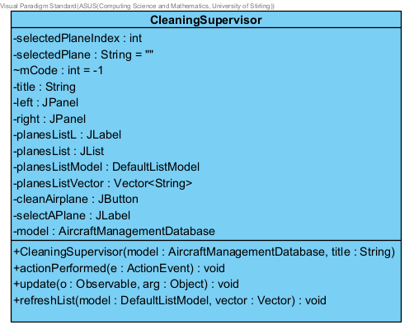

// Clean Airplane button is clicked - Depending on the current status of the selected MR, changes it to either CLEAN_AWAIT_MAINT, AWAIT_REPAIR or READY_REFUEL .Makes a connection between the CLEAN_AWAIT_MAINT, AWAIT_REPAIR and READY_REFUE. This will not receive 3 enum from different enum at the same time

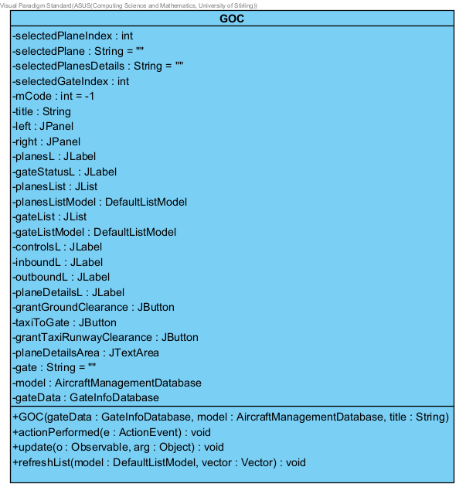

//Pressing the Grant Ground Clearance button - Changes the status of the MR to GROUND_CLEARANCE_GRANTED. This keeps collecting a single GROUND_CLEARANCE_GRANTED enum from the AircraftManagementDatabase class, which prevents receiving different enum.

//Pressing Taxi to Gate - Changes the status of the MR to TAXIING and the status of the Gate to RESERVED, Makes a connection between the MR and the Gate.

//Pressing the Grant Taxi Runaway Clearance - Changes the status of the MR to AWAITING_TAKEOFF and the status of the Gate to Free. Removes the connection between the Gate and the MR.

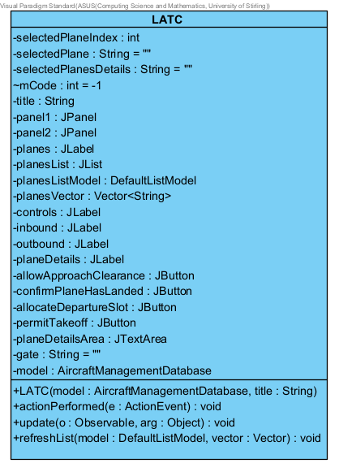

// Allow Approach Clearance button is clicked - Changes the status of the selected MR to LANDING. To continuously receive the enum that the plane is landing from LANDING enum.

// Confirm Plane Has Landed button is clicked - Changes the status of the selected MR to LANDED. To continue to receive news that the aircraft has been landed from LANDED enum.

// Allocate Departure Slot button is clicked - Changes the status of the selected MR to AWAITING_TAXI. In order to ensure that 2 aircraft do not land and occupy space in the same place at the same time.

// Permit Takeoff button is clicked - Changes the status of the selected MR to DEPARTING_THROUGH_LOCAL_AIRSPACE. To record the part of the airport that handles departing passengers from the DEPARTING_THROUGH_LOCAL_AIRSPACE enum.

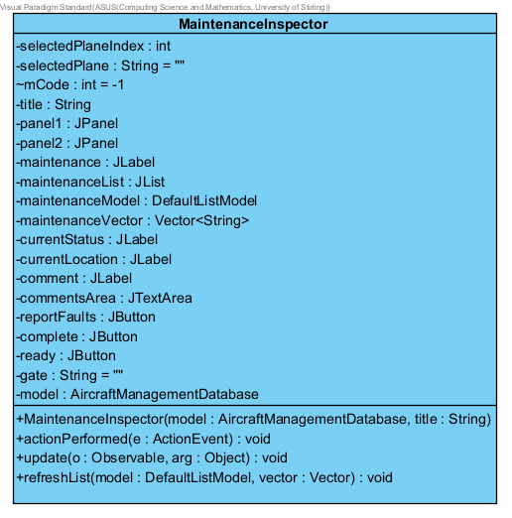

// Ready button is clicked - Depending on the current status, changes the status of the selected MR to either OK_AWAIT_CLEAN or READY_REFUEL. For the record the aircraft has been safety checked, refuelled and cleaned, makes a connection MR to either OK_AWAIT_CLEAN or READY_REFUEL enum.

// Report Faults button is clicked - Depending on the current status, changes the status of the selected MR to either FAULTY_AWAIT_CLEAN or AWAIT_REPAIR. To receive reports on the cleanliness and maintenance of the aircraft. makes a connection MR to either FAULTY_AWAIT_CLEAN or AWAIT_REPAIR enum.

// Complete button is clicked -Changes the status of the selected MR to READY_CLEAN_AND_MAINT, to document that the aircraft has undergone all inspections in perfect condition and to rule out all dangerous states of the aircraft from READY_CLEAN_AND_MAINT enum.

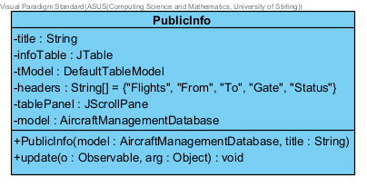

//Goes through all the enum from the Detected Management Records

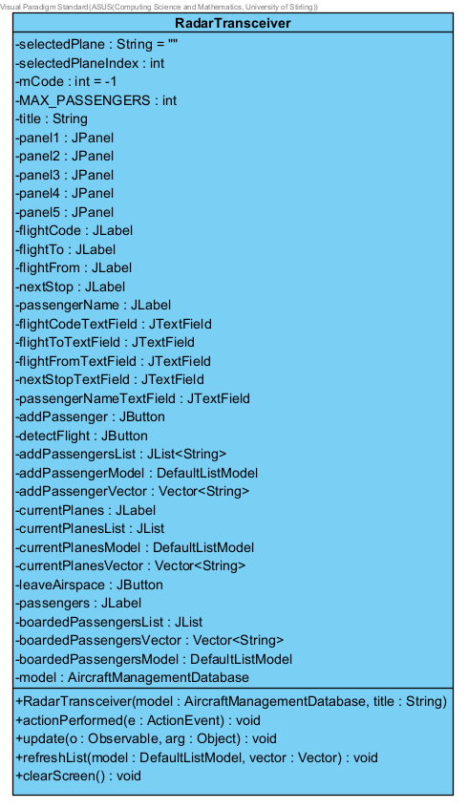

//enabling the leave Airspace button only for MRs with status IN_TRANSIT or DEPARTING_THROUGH_LOCAL_AIRSPACE. To show the part of the airport that handles departing passengers from the DEPARTING_THROUGH_LOCAL_AIRSPACE enum or show up some passengers transit another country from IN_TRANSIT enum.

// Detect FLight button is clicked - Creating all the necessary objects for the MR and setting its status to IN_TRANSIT or WANTING_TO_LAND depending on nextStop.

// Add Passenger button is clicked - Adding passengers to the Jlist at SAAMS airports.

// Leave Airspace button is clicked - Changes the status of the selected MR to FREE. To ensure that MR is not occupied.

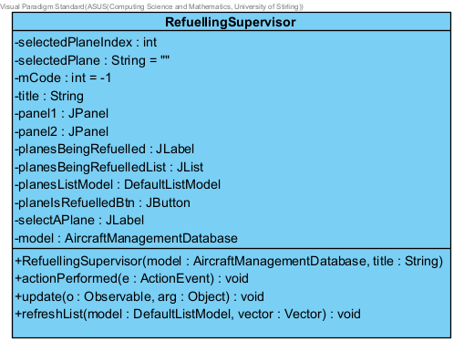

// Plane Is Refuelled button is clicked - Changes the status of the selected MR to READY_PASSENGERS. Makes a connection with the MR enum.

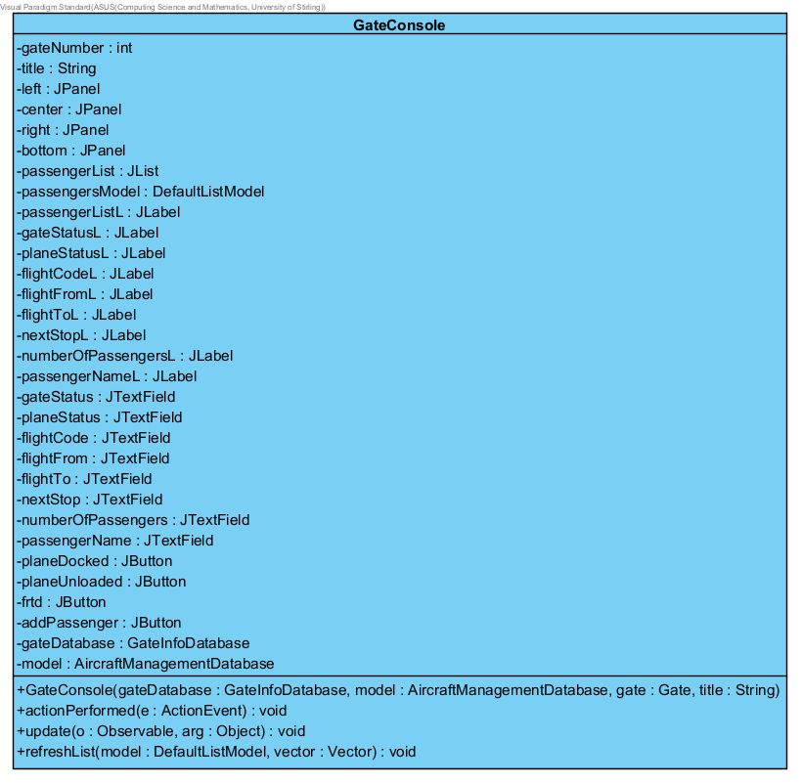

//Pressing the Plane Docked button - Gate becomes OCCUUPIED, MR becomes UNLOADING. Makes a connection between the MR and the Gate.

//Pressing the Plane Unloaded button - Passenger list cleared, MR becomes UNLOADED. Makes a connection with the MR enum.

//Pressing the addPassenger button - if the textField is not empty it adds the Details to the PassengerList until it is full. To prevent over-seats on existing aircraft.

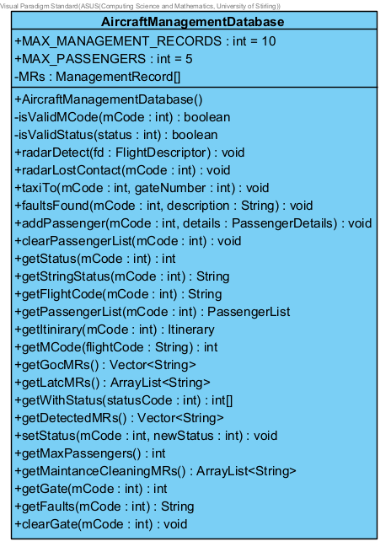

//Finds a managementRecord whos status is marked as 'FREE'. If one is found, forwards the descriptor.

//Get the MRs from the Radar Transceiver that will go to GOC, A vector of the flightCodes of MRs that have statuses different from FREE and IN TRANSIT

//Get the MRs from the Radar Transceiver that will go to LATC, ArrayList of all MRs that have status different from FREE

//A String Vector of all ManagementRecord Flight Codes whos status is not "FREE"